Vision:
To strengthen and invigorate individuals, families, and communities

Mission Statement:
We are committed to provide quality primary health services that are affordable, accessible and appropriate for all members

Values:
Integrity Respect Professional
Holistic Honesty Fairness
Confidential Dignity People Focused
Nonjudgmental Collaborative
---------------------

The position that the Porirua Union and Community Health Service advocates in relation to Te Tiriti O Waitangi is one that links customary and traditional parts of whanau with a medley of inclusiveness, a throng of diversity and a collection of interpretations
We celebrate the common interest and vision intended by
Te Tiriti O Waitangi

Overview of 2016/2017.

- Background:
The Porirua Union and Community Health Service is 26 Years old. The Team is continually committed to provide quality primary health care services that are affordable, accessible and appropriate for all members.
The care includes Acute Medical Care, General Health Consultation, Diabetes Education & Management, CVDRA, Asthma Management, Immunisation, Family Planning, Sexual Health, Health Screening – including Cervical Smears, Mammograms, Midwifery Services, Refugee and New Migrant Health Services, Community Health, Health Education and Lifestyle Changes: Smoking Cessation, Exercise and Nutrition.

- Personnel:

Domestics: Paula Atatagi

Nurses: Malelega Tapu
Maire Christeller
Ma’u Pauta
Sarah Masters
Litia Gibson
Uputaua Suniula
Tegan Jones
Sifila Mailau

Community Workers: Te Au Marama
Jacqueline Biggins

Social Worker Melisha Isaako

Midwives: Sarah Scanlan
Kahurangi Ross
Joanne Evans
Siobhan Connor
Stirling Igasia Holdford

Doctors: Lilani Weerakkody
Ket Ung
Bryan Betty
Bhavna Mistry
Simon Saena
Sapna Samant
Prasanna Govindaraj
Yukio Flinte
Prithivirajan Kasirajan
Howard Livingston
Nadine Kuiper

Podiatrist Paul Maddox

Physiotherapy - Director Atif Razvi (North City Physiotherapy)
Diabetes Specialists Jeremy Krebs
Lorna Bingham

Clinical Pharmacist Linda Bryant

Skin Specialist Nurse Debbie Rickard
Hearing Therapy Clinic Linda Hatten
Skin lesion minor surgery John Langham
Arthritis Clinics Iuliano Tinielu
Pasifika Navigator Ine Faleafaga
Receptionist: Vaelei Ala
Cindy Strickland
Demelza Thomas
Sally Aliva

Primary Care Health Assistant Demelza Thomas

Administration: Jacqueline Ward (Senior Administrator)
Pakileata Palauni

Clinical Coordinator: Ioana Viliamu Amusia

Manager: Hiueni Nuku

- During the last twelve months we have had achievements and changes:

- Continuing of the In house Diabetes Specialist sessions & Clinical team presentation.
- We are so good with our capacity this year so far with GPs. We mostly always having available appointments during the day.
- Evolution training for the Primary Health Care Assistant especially for the recalls.
- Updating session with Staff and Management team on Evolution
- GP phone triage started and extended to cover Monday to Friday in the morning.
- GP early clinic started once a week.
- PUCHS had a stall at the Creek Fest and well supported by staff focus on rheumatic fever and Youth.
- We had a staff team building day in April organised and facilitated by Ara Swanney. Not everyone available to attend but those who attended discovers how secrecy, power trips, and resentment can erode trust and respect in the team and that honesty, respect, growing awareness of other’s needs and looking after one’s self can lead to a more supportive and efficient environment to work in. We finished the day with an Intention 2016: We intend to face challenges and build confidence in order to solve problems by understanding the roles and differences in the team and use our strengths to be proactive and uplifting with open discussions, love, care, and respect.
- Due to the cutting of our Funding by Capital & Coast DHB, it was sad to lose our midwives. We did our best to support them during the process of their redundant in August 2016. We had a farewell share lunch with them on their last day. They continued to look after our existing patients to the end of December 2016 and two of them continue as an independent LMC.
- Youth night had been very successful and huge benefit for HYPE and our youth.
- Presentation from WINZ at one of our staff meetings. It was a good update for our staff.
- Tegan Jones is one of our nurses moved on to her whanau in Gisborne. We missed her and she was a great Maori nurse. We had a farewell lunch with her and it was great to see also one of our former nurse, Claire Frater as she came to the farewell.
- We welcome our new Primary Health Nurse, Sifila Mailau as she was a Primary Health Nurse at Waitangirua Medical Centre for 6 years.
- Dr. Raj (Prithivirajan Kasirajan) finished in December due to change of his family circumstances. We missed him as he was a great GP. We have had a farewell lunch with him.
- Acknowledgment of Sally Aliva and Demelza Thomas as they both completed their Courses. Sally with the Certificate in Mental health and Demelza with the Certificate in Pacific Nutrition.
- Acknowledgement of Dr. Prasanna Govindaraj as she completed her Fellowship in December.
- Welcome of our new locum GP, Dr. Howard Livingston and also our new permanent GP, Dr. Nadine Kuiper.
- Staff completed updating the CPR both clinical and non-clinical staff.

- Governing Board members:

Kaumatua Samuel Pewhairangi

Stakeholders/Supporters rep: Ian Frater (Chairperson)
Ara Swanney

Community Representatives: Sitapeti Palauni
Alan Marama

Patient representatives: Rev. Patrick Fenika
Rex Harniss (secretary & Treasurer)

Maori staff representative: Demelza Thomas

Pacific staff representative: Paula Atatagi

General Practitioner: Dr. Bryan Betty

Clinical Coordinator: Ioana Viliamu Amusia

Manager: Hiueni Nuku

- Patients:

5.1 We started the year with the enrolled population of 5,817 and at the end of the year, this had increased to 5,965. There are numbers of patients who moved to other places and other medical centers. There are numbers of new patients enrolled with us in every quarter.

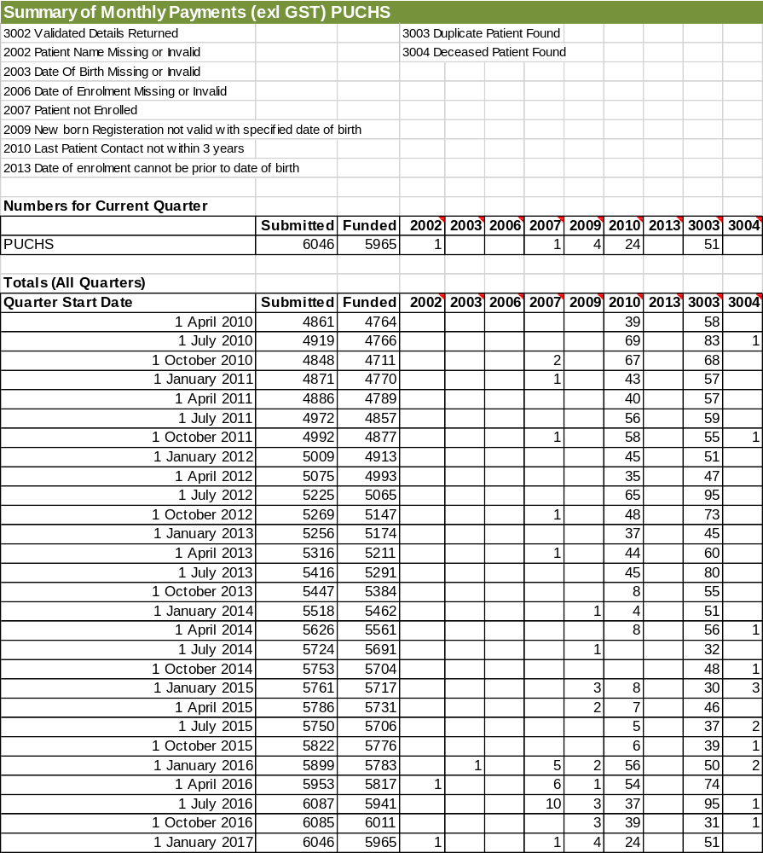

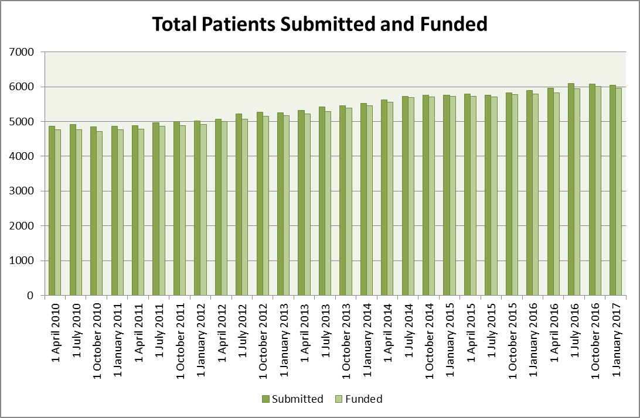

5.2 LOW - COST ACCESS FUNDING POPULATION.

APR – JUN 2016.
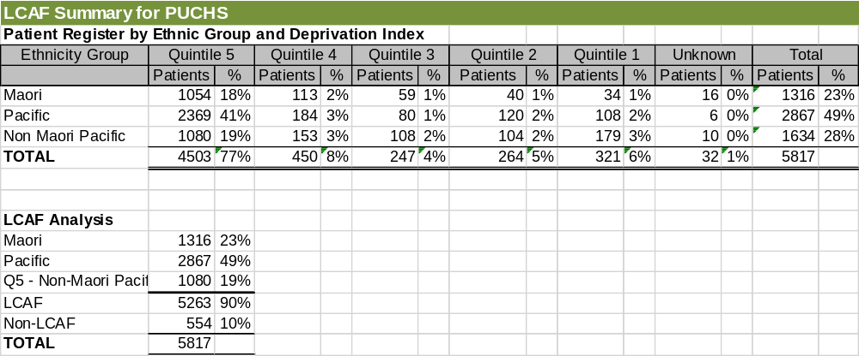

JAN – MAR 2017.
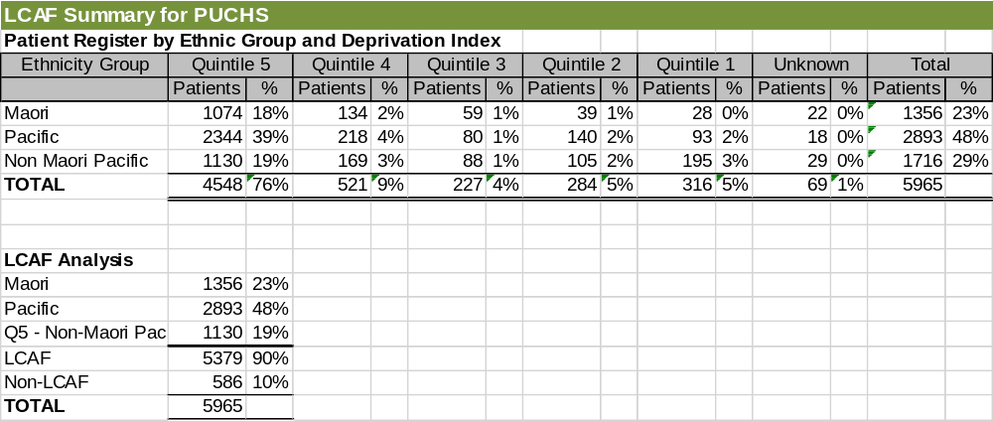

  - DISTRIBUTION OF PATIENTS BY QUINTILE (DEPREVATED).

APR – JUN 2016.
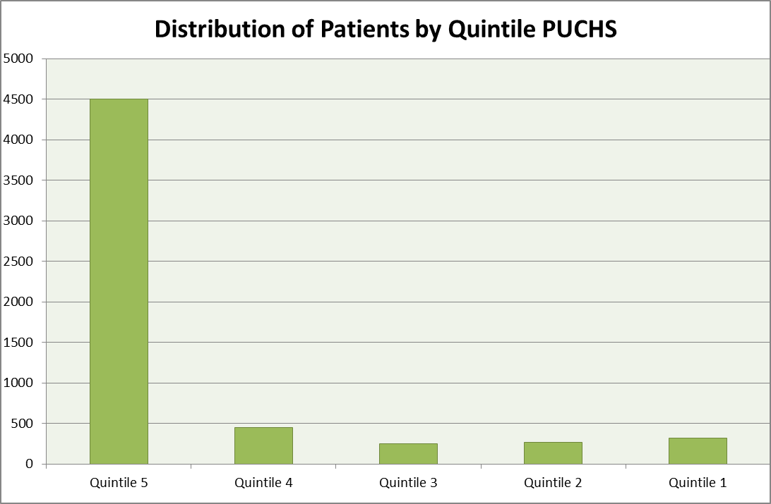

JAN – MAR 2017.
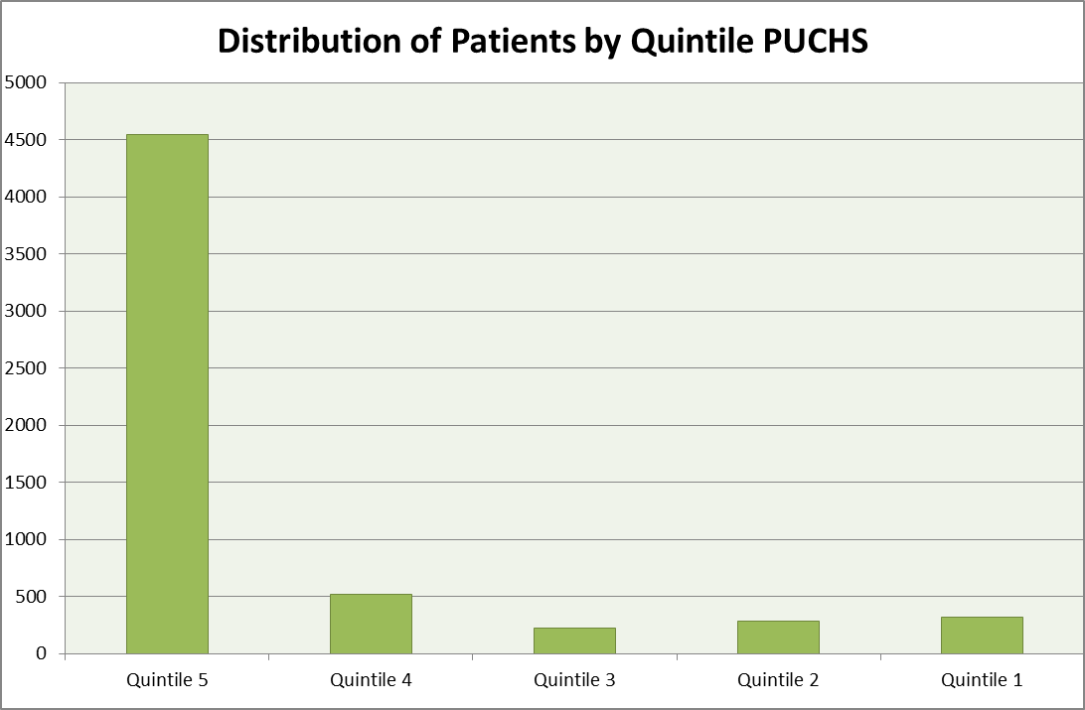

  - Ethnicity Summary for PUCHS.

APR – JUN 2016.
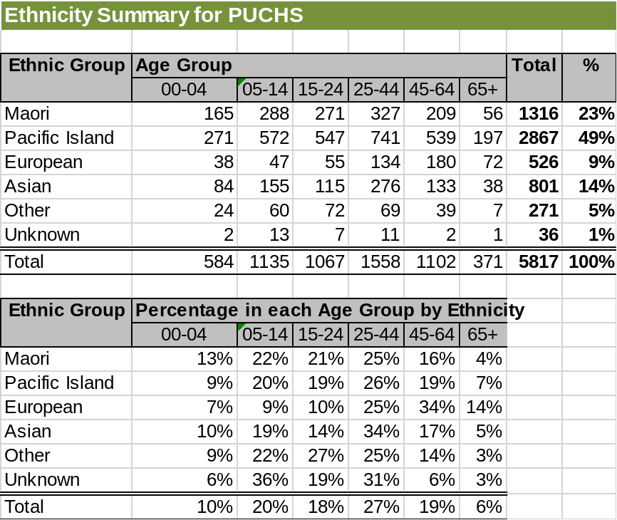
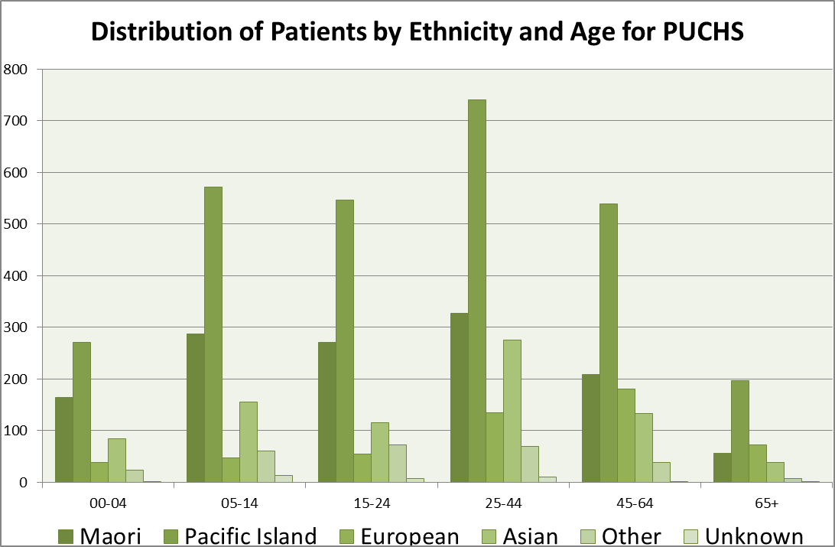

JAN – MAR 2017

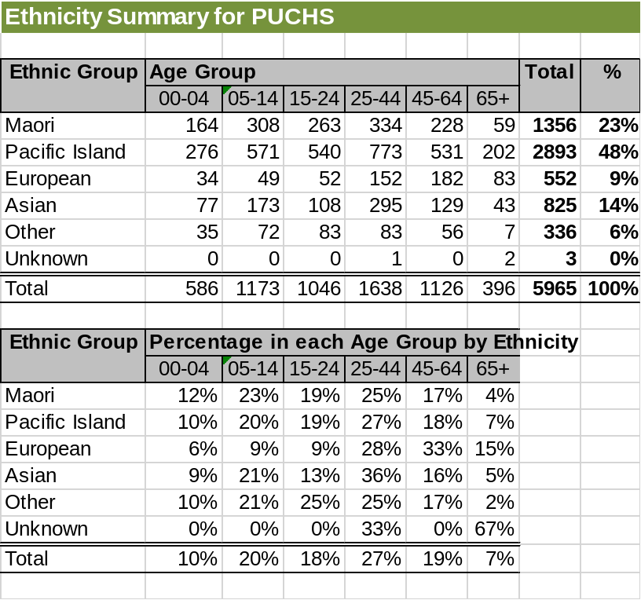

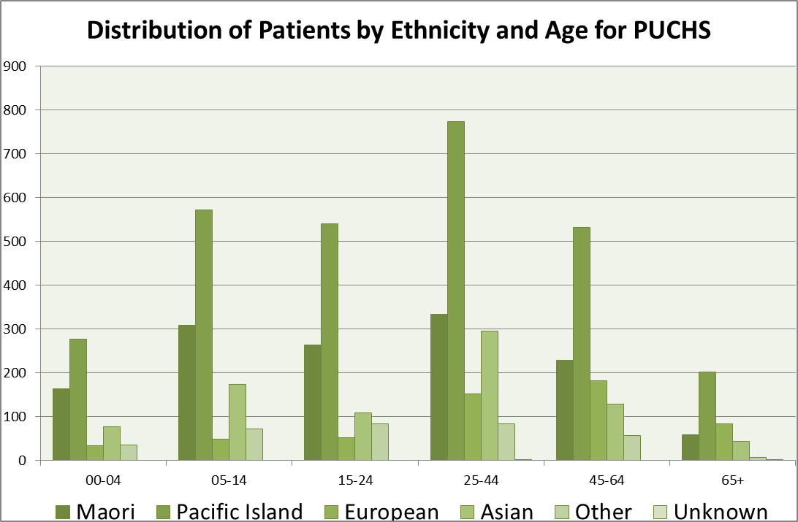

  - AGE GENDER SUMMARY FOR PUCHS.

APR – JUN 2016
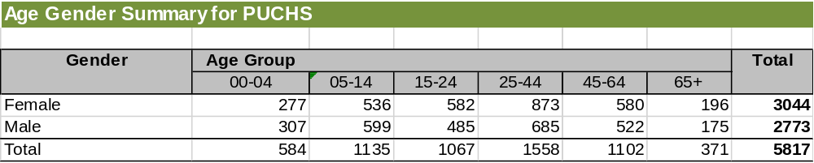

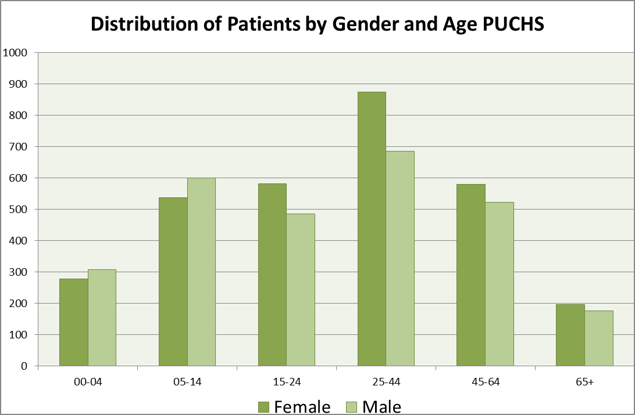

JAN – MAR 2017
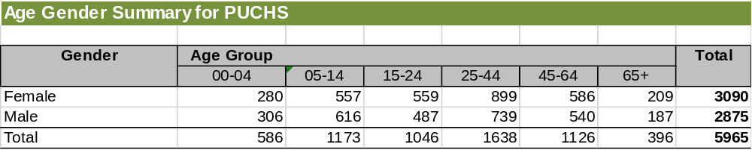
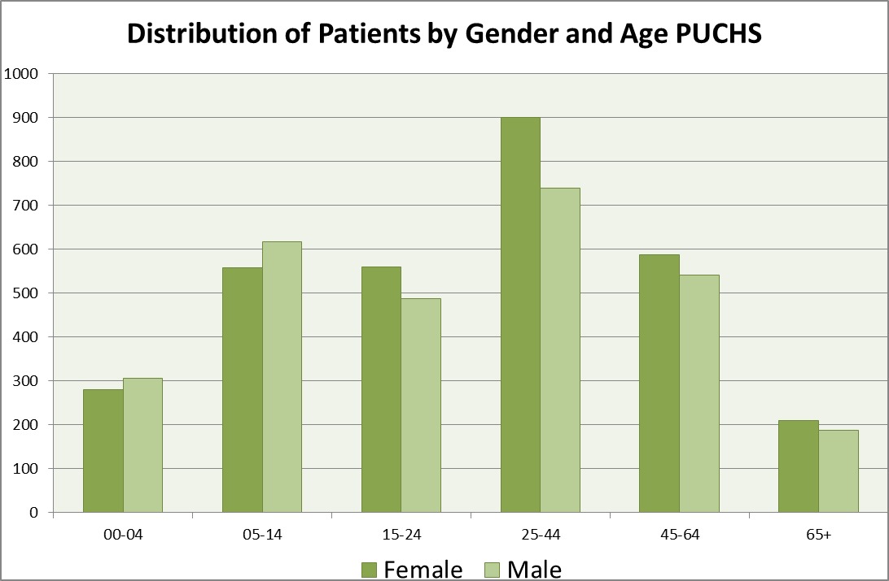

  - UTILISATION REPORTS.

JAN – MAR 2017
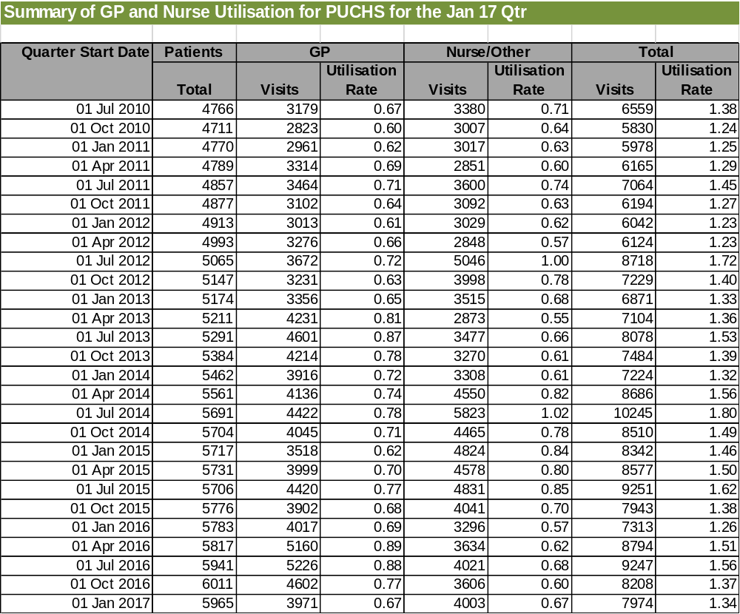
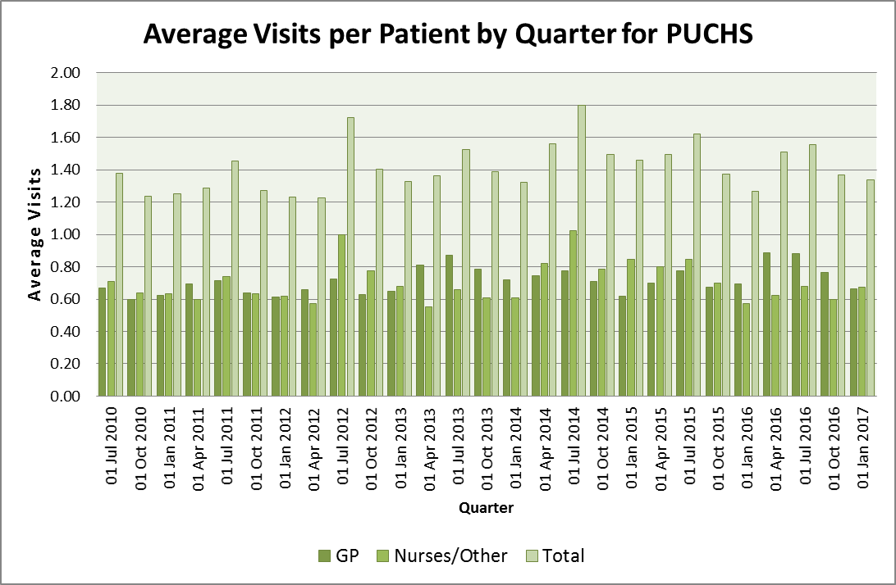

APR – JUN 2016

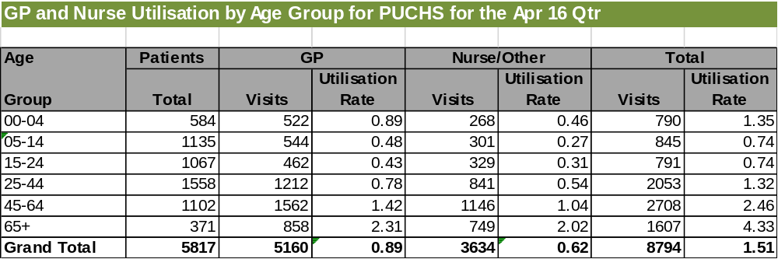

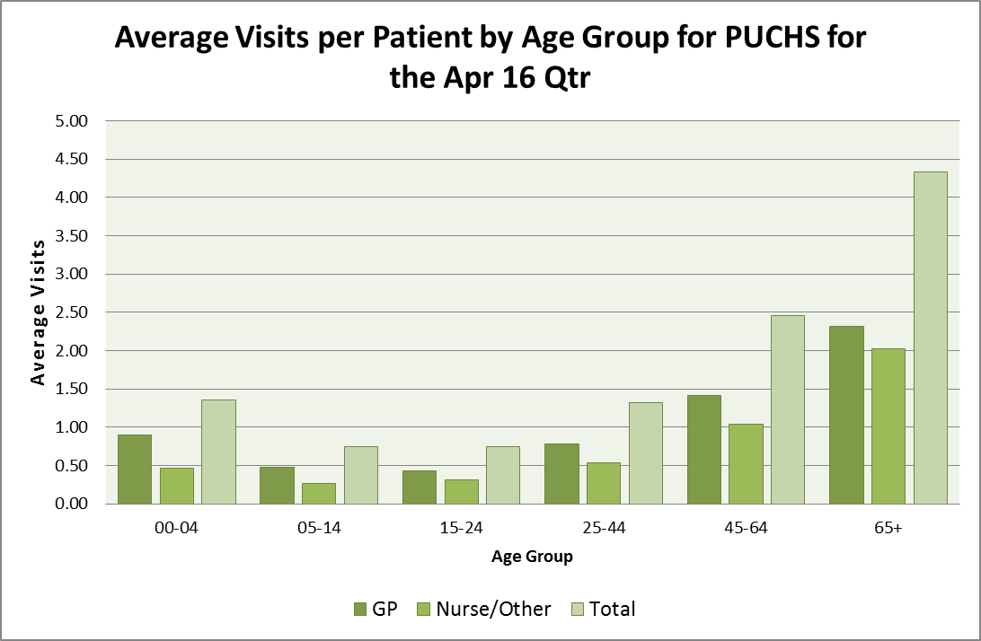

JAN – MAR 2017
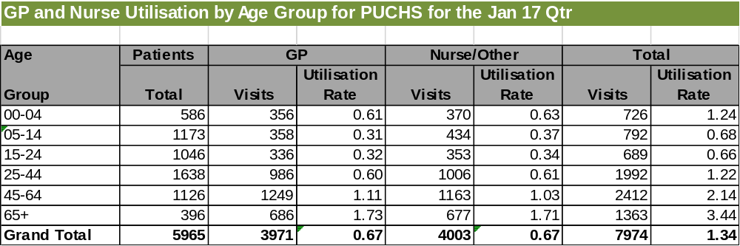

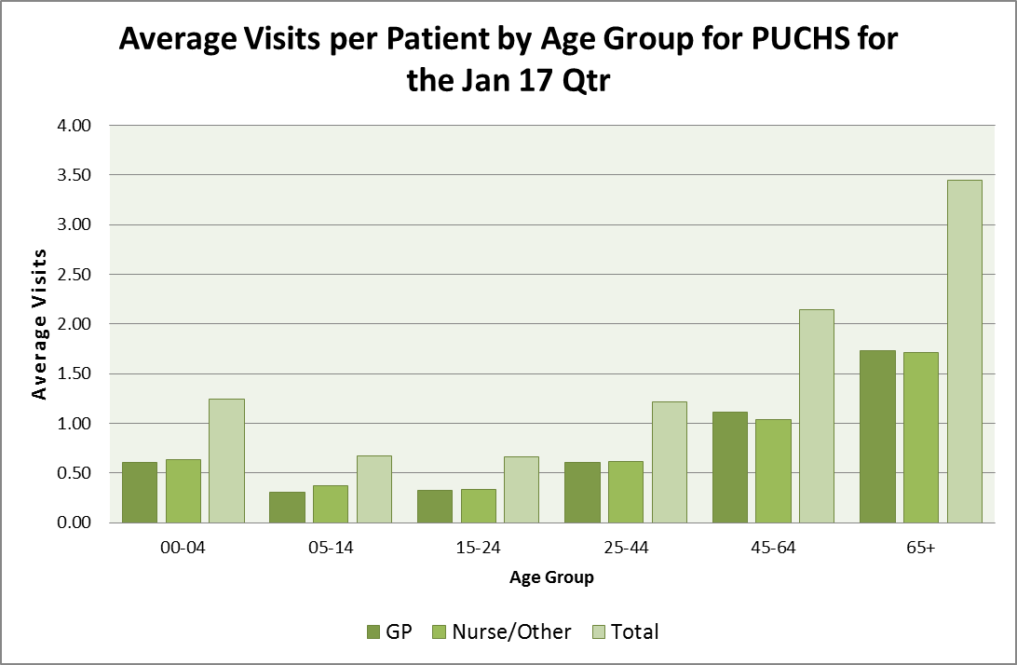

APR – JUN 2016
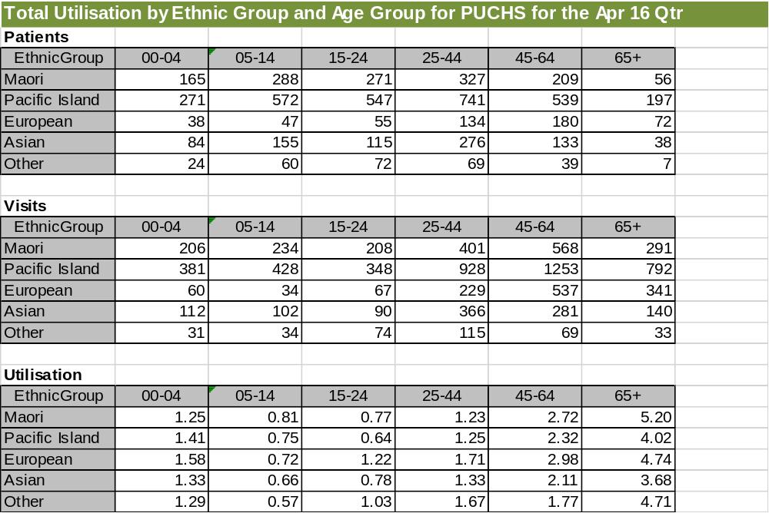

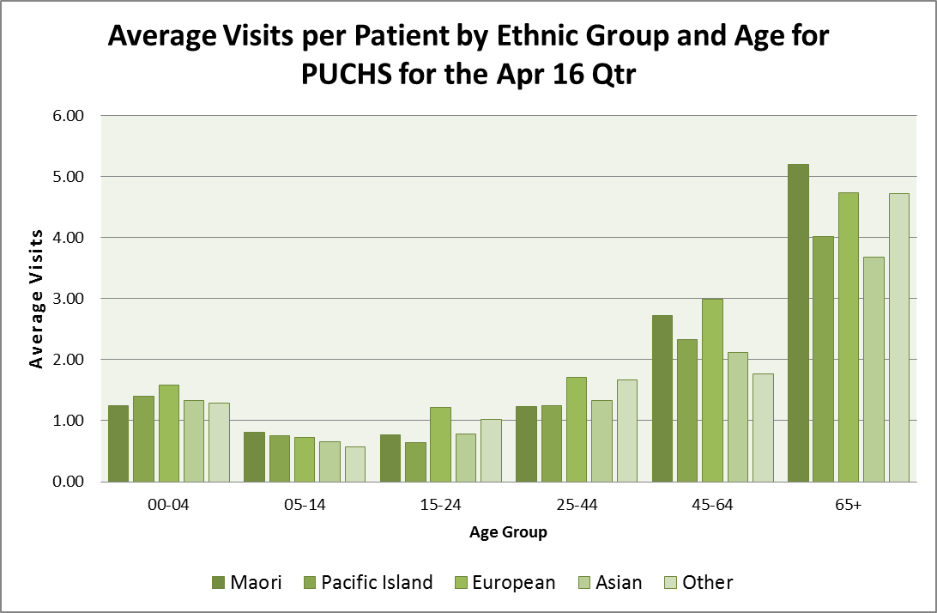

JAN – MAR 17
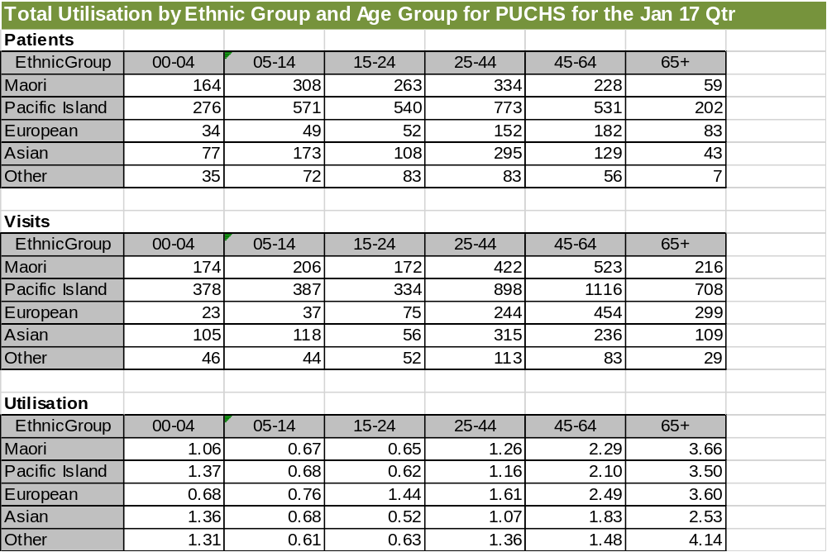

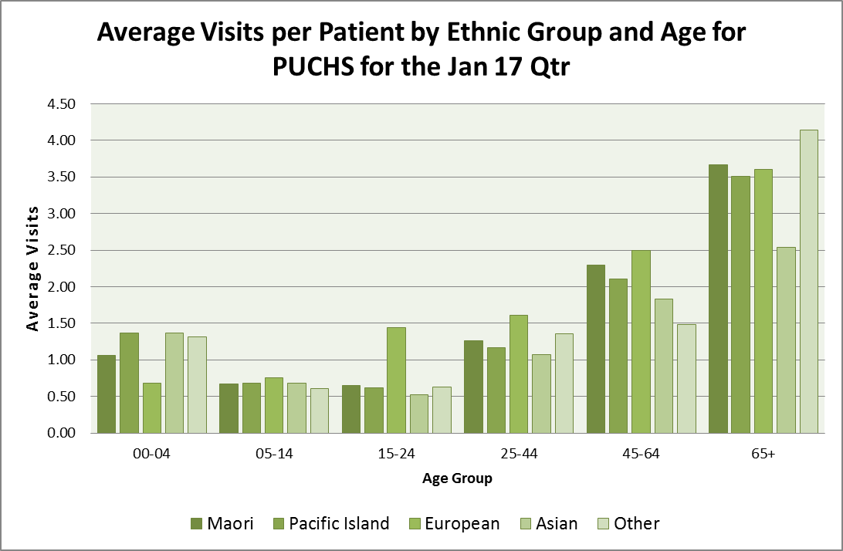

- THE MINOR SURGERY CLINIC:

This service has continued to offer an affordable and comfortable environment for PUCHS patients to easily access the practice for minor surgery. The clinic continues to run once a month with five thirty-minute appointments available with visiting GP, Dr. John Langham and PUCHS Primary Health Nurses, Tegan Jones, and Sarah Marsters. Clinic appointments are typically booked on the opinion of the patients own GP for minor surgical procedures or alternatively for a second-opinion in light of Dr. Langham’s advanced knowledge of dermatology. These clinics are a vital lifeline for our patients that may otherwise deter seeking help for their medical issues or fail to meet the criteria for referral to secondary care. Due to the regular and easy-access nature of the Minor Surgery Clinic – we are able to prevent complications such as infection/sepsis and skin cancers from developing, thus cementing the efficacy of offering such a service.
The clinics are so well utilised that they are typically booked out two months in advance. Dr. Langham is briefed the week prior by the Primary Nurse Tegan Jones and Sarah Marsters as to the presenting issues of the patients, and patients receive phone call reminders leading up to clinic dates to reduce the possibilities of forgotten or lost appointments. Patients will typically have a follow up appointment within 10 days of their surgery with a practice nurse for wound review. Patients continue to be so very grateful and pleased with their health outcomes which are directly related to the presence of this Doctor-Nurse clinic at the “health care home” of PUCHS.

- Rheumatic Fever.
It is very pleasing to see some positive results for the improvements of this third world disease, as a health provider in the Cannons Creek community we are excited and thrilled to be a part of this important change Rheumatic Fever awareness campaign continues throughout our clinic and the community we serve. This is done through our community work especially with Teau our community health worker, and well connected to Cannons Creek Community. Many of our Nurses are also well connected with our own Pacific Cultural communities and church groups
We continue to serve our Communities with care and respect and continue our relationship with churches and communities leaders. Ongoing assessments for all our patients, who walk into our clinic continue to be assessed for a sore throat as needed.
We kept updating and reminded all staff of the importance of this project including meeting the requirements re Rapid Response to our Community and prevention of Rheumatic Fever.
PUCHS continue to promote prevention of Rheumatic fever to our community through community meetings with our Community Health Workers, Community Leaders at our Board meetings and clinical staff.
We having Youth worker to enhance our service for ‘Youth’ – this was our opportunity to discuss with young people their needs, what they believe health is about and how practices i.e. PUCHS can best serve their needs. Our target population is Maori, Pacific and Quantile 5 aging from 9-30 years of age. Many opportunities are given to discuss Rheumatic fever and prevention.
Ongoing concerns with many families are the cold damp houses and the multiple issues that are associated with. The next step for our clinic is supporting families in improving Health Literacy and promoting well health at home for families.

We continue to use a model that incorporates holistic health care i.e. Te Whare Tapa Wha. The healthy housing referral scheme (RPH) has been utilised, this has been supportive to our patients and reassuring for us a GP provider knowing that the colossal job of liaising with community providers is now an organisation on its own. Our aim is reminding staff and encouraging families to be referred on to the ‘Healthy Housing Hub’ one of the aims for this is that our fanau live in Warm, Dry and Safe Homes. Through this, we encourage, promote and advocate for healthy families and prevent Rheumatic Fever.
PUCHS also promotes this campaign not only through the use of the Advance form for sore throats but also through community events. This is done via community meetings with our Community Health Worker and clinical staff. They continue to mention the importance of acknowledging ‘a sore throat get it swabbed’ but also through the big events. Many of our staff have worked overtime and in the weekends. Creekfest is an annual event in Cannons Creek Porirua where multiple agencies i.e. Health and Social come together to promote, educate and improve the awareness of health services available.

- Youth Friendly Health Service for Young People at PUCHS (HYPE):

HYPE (Healthy Young People Energised), continues to be an important part of our clinic. The Community we serve is youthful and vibrant, our youth and children make up a large percentage of the PUCHS enrollment, therefore early engagement and encouraging relationship building with this group are important for the growth of PUCHS. This early engagement can prove to be an important tool in the early intervention in young peoples’ health choices. Several events have been organised so far this year, including a Youth Week event, and Youth Committee meetings which involve our young people. The HYPE banner has been very useful in advertising our youth friendly clinic and when we have taken offsite to other community events.
Youth Social Worker has been proactive in working with young people to connect them to external services i.e WINZ, Counselling, Career support at The Learning Shop, Budget advice and working closely with parents of our young people.
In doing this there has been a natural progression in building good working relationships with different agencies such as Volunteer Porirua and The Learning Shop but more importantly the parents of the young people. These parents have been key in encouraging their young people to come in and be seen in the HYPE Youth clinic or attending appointments with the Youth Social Worker. Although DNA’s still exist the HYPE team continue to reassure our young patients we are here for them or the parents of these young people.
One of the keys to working with our young people is the ‘continue follow-up’ when referrals have been made externally to other services. The transition to these services or support to be there for the young person is vital in helping to create an atmosphere of encouragement and providing a safety net for our young people.
Practicing from a strengths-based approach is effective in achieving this.
Also, proposing the need to have a newsletter to be a tool in promoting health and engaging our young patients with HYPE has been a positive hand-out in informing our young people of what is happening in HYPE and what is to come.
Although the Youth Social Worker, primarily work with our young patients, she has taken on cases outside of the youth age bracket of 14-24 depending on her capacity of work.
She has been working with our elderly patients in support of better living conditions and advocating on their behalf to MSD and social unit housing.
This has been good learning as MSD and social unit housing has been amazing in helping her to understand how they work and how we can achieve in making our patient's applications for a home effective.
Building relationships with our young patients have been key for the HYPE team and have allowed for us to see a great response from our young patients in terms of trust and communication. Our young patients have trusted the HYPE team to provide the support and guidance to work together as a team

- PUCHS More Heart & Diabetes Checks (CVDRA)
KARO Data Management extracts the PUCHS data for the PHO. Best Practice and Procon Dashboard are the IT tool that clinicians use to collect patient information and Medtech Evolution is the Patient Management System that is used for patient records.

At the end of March 2017, our total of CVDRA completed has increased from 260 to 267 at this quarter. There were 1 (0%) new patient, 3 CVDRA already completed in last 5 years, and 1 new CVDRA within the guideline.

The total patients aged 15 and over is 4,227, the total patients within the guideline are 1521 and patients with CVDRA completed are 1368 (90%). The target is 90%.

PUCHS has continued focus on achieving more CVDRA checks with regular use of ‘dashboard’ in the nurse’s daily clinic. GPs and nurses can refer patients to this clinic opportunistically for those who require updates on heart and diabetes checks. The intention of this is to streamline GP visits while capturing the information needed for patient well-being and of course our stats.
Staff also monitoring future appointments to identify those requiring these checks and note on the template for the GP and ‘dashboard’ nurse.

Our staff is encouraged to use the patient dashboard which highlights those overdue for health checks.

Our staff has remained static this year and we employed another new GP in March and it is a tremendous help during the last quarter.
A new locum GP started in January for three months. He was a very experienced GP and it is making a big difference of having this kind of capacity to serve our community.
We continue to deal with the issues related to the population demographic at PUCHS. 70% Pacific and Maori of the enrolled population and 90% high needs enrolled population.

Our greater numbers of high needs and low socio economic patient base mean it is necessary to work harder to ensure patients have access to our services and are able to attend their regular appointments.

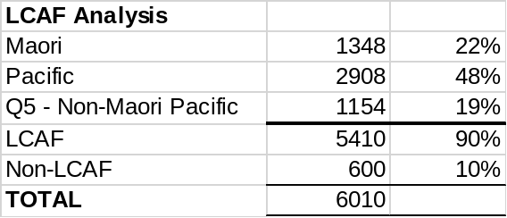

Transient patients make contacting them quite difficult at times, which of course has an impact on recalling patients, for their regular health checks. Lack of transport, regular changes of physical addresses and phone numbers, lack of phone service all add to the issues that PUCHS faces in encouraging our patients to attend appointments.

- Diabetes & Community Outreach:
Diabetes Clinic- There are two diabetes clinics each week. We also have Pharmacist and dietician who together provide a wrap-around service for our diabetes patients, including pre-diabetes.

We have a bi monthly diabetes podiatrist clinic. The diabetes specialists Dr. Jeremy Krebbs, along with a diabetes nurse specialist from Capital & Coast DHB continue their combined case conference sessions with our GPs and nurses every second month. Our doctors and nurses are encouraged to present cases to the multi-discipline clinical group, this includes, pharmacist, dietician, social worker, and community health workers We aim to improve diabetes outcomes, for the individual and their whanau, the clinical staff gain more knowledge and grow with confidence in the management of PUCHS diabetes and other long term conditions population. PUCHS is a very high needs clinic, access, affordable quality health care is crucial together with staff who have an understanding and ability to work with this community. We have regular well utilised onsite appointments for Podiatry (Paul) care, offer on fortnightly basis, which works for our clients. Paul has been with PUCHS for many years, his rapport with our patients is imperative to the care and understanding in managing diabetes foot care.
Both our diabetes nurses are encouraged to attend education sessions to improve their specialty care. Mau continues to be supported to attend CCDHB diabetes nurse specialist groups, there she meets with other diabetes nurses who discuss and regularly share information. This includes sharing the recently launched CCDHB ‘Hypoglycaemic’ info easily available for our Practice nurses to use and feel confident to treat.

As well as the special clinics patients are also able to choose another day to see either their own GP or one of our nurses for their diabetic reviews.

Once per week, we have an outreach nurse who visits our homebound patients, the majority of which are diabetes patients. This is where the family and the patient is supported to cope with the diabetes condition.

PUCHS has also been able to support one of our nurse champions to attend the recent diabetes conference held in Rotorua. She is also given time to attend the regular diabetes nurse DNPP forums.

All nurses are encouraged and supported to attend the diabetes nurse peer review study evening sessions.

There was a slight increase in the percentage of ADR in the last quarter of which reveals some changes to the ways this clinic is held at PUCHS and the use of SMS reminder to the patient that are due for diabetes review.

Person/whanau focus
- Diabetes display in the waiting room
Resources have been identified and some obtained from the National Heart Foundation (NHF) and Diabetes NZ. The booklets on Healthy Eating for Babies and Toddlers (MoH) are used as a general resource by the nurses, as well as the NHF pamphlets for healthy Eating in Tongan, Samoan, and English. We now have HealthTV installed in our waiting which includes educational information on healthy eating. PUCHS continues to work around improvements with health literacy, utilisation of visual models, visual aids used from PC, internet websites such as Heart Foundation NZ, Kidney NZ, and Diabetes NZ. The use of graphs from the ‘common form’ and referrals to keep us up to date and informed also supportive and by working closely with other multiple agencies, this includes – retinal screening, renal specialty or home supports as required such as care coordination, Pacific Navigators, Maori Health Supports
- Diabetes self-directed care groups
We have successfully delivered and completed four self-management group sessions during April and May 2016. These were led by the PUCHS nurse champion team, including community health worker, nurses. Also involved the PHO dietician and clinical pharmacist.
The last session involved a panel discussion with attendees encouraged to ask any questions they had about their diabetes condition. The panel team included Miranda Walker (Renal and Diabetes specialist from CCDHB), Linda Bryant (Clinical Pharmacist), Rachel Davidson (Dietician), and PUCHS nurse champions. The attendees included family members, some young people and we also had members from other PHO groups.
- Early intervention - Understanding what children think about diabetes
We are aware that we have a high number of patients with pre-diabetes conditions, and therefore PUCHS has made pre-diabetes a focus of care for our practice and our community. Our diabetes team is looking at clinical changes that will help to capture this group and work with them to improve outcomes.

Challenges and Solutions
Our biggest challenge remains how to motivate people with diabetes to make positive life style changes necessary to improve their long term health outcomes.

One of our biggest challenges is encouraging our most complex patients with high HbA1c readings over 64 to commence insulin. We have been able to start an increasing number of people on insulin as their condition dictates and we acknowledge the support of the reps from Novo and Lilly for prompt supply of insulin pens.

We also investigate our diabetes data to identify those patients with diabetes and declining renal health problems with the intention of encouraging them to utilise the services that we offer.

Our GP registrar together with our clinical pharmacist are currently working on a project to identify patients who pre-diabetes and with microalbuminuria. An ACR check will be offered to all patients identified as pre-diabetes. The focus is to identify and have early engagement with those patients with early onset of diabetes in order to improve their health outcomes.

Tobacco Report
We continue to ensure health promotion activities for smoke cessation carry on here at PUCHS. This is done both within the clinic and outside of the clinic, during health promotion activities out of clinic smoke cessation remains a priority health message for our community with supports offered to individuals or families. The community health worker is up to date and aware of her role to promote this at her events, supported by clinical staff. Kokiri Marae smoke cessation program provided an update with PUCHS, by having the quite coach staff on site we hoping to have improved results. The clinic continues to use Dashboard to update and remind staff of its obligation to promote this important health message. We have discussed our HCA to support this activity also once she has an improved understanding of how she fits in with this work, Kokiri Marae also is doing the Smoke cessation update for all staff. Clinical staff are also aware and have been referring via the online quit line referral option should individuals choose this option.
Visual posters provided by Pfizer of smoke cessation continue to provide a powerful visual health message with patients commenting on these, setting the scene either in the corridor or inside consult rooms. We continue to also use health TV to promote this program at different times throughout the year.
Our youth are a very mobile population, difficult to keep their mobile numbers updated also. Parents have the same number as some of our youth, sometimes difficult to get correct information.
Strategy, to get the Kokiri Marae smoke cessation program up and going here at PUCHS.

- VLCA Practices Sustainability Initiative Report
Our aim at PUCHS is to continue to work hard to achieve better health outcomes for our patients with our main focus being on our strategic goals. We must be able to continue to offer high quality and accessible clinical care to our patients. We strive to improve our capacity and we intend to maintain our reputation as a teaching practice.
As a teaching practice, we welcome 4th-year medical students from Otago University in their intensive teaching week. We also from time to time have 3rd-year medical students on one-day placements. PUCHS continues its relationship with the local nursing schools, taking a 2nd year and 3rd-year students from the Maori, Mainstream, and Pacific Nursing School at Whitireia. Our midwifery students continue to work closely with our Midwives.
Last year for the first time we placed a social work student from Whitireia on a three month work skills project. Again this year we have been able to place another social work student for a three month period. It was due to the research from our first student that we were able to apply for a grant to employ a youth social worker for a nine month period this year. This is proving a great benefit to our young people.
The cervical smear ‘self-sampling’ research with Massey University was completed in June of this year. Thanks to our nurses who became very involved in this project and to the patients who were prepared to participate.
Health Promotion events this year so far include:
Festival of the elements – celebration of Te Tiriti o Waitangi here in Porirua. Creek Fest, a huge community event promoting good health practices, and more recently we have started internal health promotion for patients in our own waiting room area with ‘Health TV.’
Since moving to Medtech Evolution in October 2015, we are pleased to see that staff is now working well with the new database. We were also asked to be a BETA testing site for the introduction of NES and NZePs. Being a BETA site brought some challenges, but the positives from that are that we received some very good training and readily available support.
We continue to promote Manage My Health and the patient portal to our patients, although the uptake has been slow. Staff are very open to this means of communication with our patients and hope to encourage more patients to register and activate their accounts. Currently, patients can access results, order repeat prescriptions, update their personal details and we are next looking at making it possible for patients to make their own appointments.

The Porirua Union and Community Health Service continue to focus on four main strategic goals, funding received through the VLCA Sustainability Initiative supports us to be able to achieve this.
1. Continuing to deliver high-quality clinical care which is responsive, affordable and accessible to the community.
2. To improve capacity and sustainability through systems and processes.
3. Maintain PUCHS’s role and reputation as a teaching practice.
4. Focus on communication, collaboration and community engagement.

We continue after reviewed the nurse and GP buddy model and this model has been working well and creates a more efficient way of GPs and nurses working together and sharing the tasks, which of course means a more seamless and responsive model of service to our patients.
We find this effective with supporting the continuity of care model. We reviewed our appointment booking system to support the continuity of Care model. We blocked off 10 GPs appointments each day on Tuesdays, Wednesdays, and Thursdays for patients that need to be seen during the day. On Mondays and Fridays, as we experience mostly busiest during the week, we blocked off one GP for the first half of Mondays and the second half of Fridays to work with Nurses clinics plus a 5 blocked off book on day appointments. This does not happen without its challenges but is one way of staying on top of our clinical practice with nurse and doctor teams. Following up their own patients and connecting with clients and their families encourages ongoing rapport with the client and families. It also ensures the same information is given out to the patient when they are dealing with the same GP/nurse and vice versa. Keeping communication open with the GP and nurse team is extremely important for continuity of ‘clinical flow’.

We are reviewing several data projects and we are working in collaboration with Well Health PHO trying to improve our data collection system. We continue to work with Medtech as we upgraded to the new version of Medtech as the Evolution. This new version comes with a new tool name CBIT, it is helpful to give us helpful data for our internal management.
As we were also asked to be a BETA testing site for the introduction of NES and NZePs. Being a BETA site brought some challenges, but the positives from that are that we received some very good training and readily available support. This new initiative introduced to us without extra costs but we were told the ongoing costing of those initiatives will be covered by us. We are concerns as we were happy to be in advance with all new initiatives with the expectation that will all come with resources to support the ongoing costs.

- Cervical Smear.
Cervical Smears offer to our community continues to be a very challenging area for PUCHS.
Though we have made great gains, we still struggle with encouraging our women to come forth and take up this important tool for recognising and prevention of cervical cancer. When there is good advertising locally or nationally by media or health promotion we have an uptake of cervical smears within the clinic.
PUCHS recently completed the ‘self-sampling’ research with Dr. Sunia Foliaki and Massey University. This was a 6-8month project where our Pacific, Maori, and Asian women were invited to participate in collecting their own ‘self-sample’ from the pelvic area. This project was aimed at the difficult to reach or contact clients especially if they were over five years without having a smear. We especially would like to acknowledge the hard work from our nurses. There are many reasons why our women may not attend clinics for their smears e.g., cultural, challenges of their lives, language barriers, health literacy to name a few. From this project, we found the women who took the opportunity have stated this process was friendlier, less intrusive, and faster once the process was explained adequately. We await eagerly the outcomes being published and note that as a clinic we have supported a research that was beneficial for our vulnerable community but also offering valuable hands on information about our Pacific and Maori women, an opportunity to hear what they want to say!
We have a large number of young women who are entitled to a cervical smear, this age group (20-24) are also an interesting group, as engaging and getting them to respond to letters or come into the clinic for smears is proving very challenging. Enticement with the voucher from Massey University was not taken up quickly! Many phone calls made by our community health workers offering vouchers were turned down, having a smear was noted not to be urgent enough to attend the clinic.
We continue to work on making changes and capturing this group to improve the uptake of a Cervical Smear.

- Health and Safety.
All equipment including Clinical equipment completed schedule checking and maintenance.
The Building Warrant of Fitness due by the end of May 2018.

- Improving Access - Community Health Worker

Highlights/Achievements
• Spirit of Rangatahi (SOR) Leadership program: Invited to join leadership team, to mentor and assist senior college students in their leadership role. School holidays.
• Living Wage campaign: as a Living Wage provider – PUCHS is very supportive of advocating and promoting on behalf of our high risk, vulnerable population. Attend Hutt Valley Launch. Presentation of submissions to Porirua City Council meeting.
• Home Grown Heroes – Study Support Centre; Social Sector Trials sponsorship re Promotion of 5 Key messages. Based at Rangikura School, focusing on raising the Education achievements of Maori and Pacific children and their families. By getting families connected and actively involved in the school community. Outcome; stronger family units, networks and connections and Successful, confident well informed and goal orientated young future leaders.
• Participated in Lifelines 2 Days ASSIST Training re Suicide prevention. Sponsored by SOR. Manager attended also.
• Participated in Ministry of Social Development: Pacific Leaders Fono. 2 Days (Auckland). Gathering Government, Non-Government and Faith based leaders to discuss programs and services around Family Violence
• Otago School of Medicine: Diabetes Research and Study. Dr. Brian Colely
• Massey University: Type 2 Diabetes Research and Study- Physical Activity and Protein, effects on blood glucose. Dr. Martin Gram
• Judge Carruthers talk at Pataka.
• Pacific Cup Annual Rugby league tournament: Health promotion Rheumatic Fever. Acknowledging Pacific Navigation Services Porirua, Tuaine Marama, Social Sector Trial- Ranei Wineera- Parai; Compass Health, Pacific Collective: Anne Allan Moetaua, Well Health PHO for resources, Norths Rugby Club: Ron Wood and for Pacific Cup organising committee and MC for continually promoting messages throughout the whole event.
• A very successful placement of Whitireia trainee Social Worker here at PUCHS. Relying on community organisations and concerned neighborhood, challenging CCDHB Mental Health Support and services. The great positive outcome for all concerned.
• Living Wage Movement- Meet Porirua City Council candidates Event– PUCHS involved in organising committee for Porirua - advocating and promoting on behalf of our high risk, vulnerable population. Successful event.
• Ministry of Social Development: Pasifika Proud: Pacific Leaders Fono. 2 Days Wellington Regional Fono. Gathering Government, Non-Government and Faith based leaders to discuss programs and services around Family Violence.
• Home Grown Heroes: Study support center based at Rangikura School; aimed at lifting success rates in literacy, numeracy and science, and well-being for high risk and vulnerable children and their families in Porirua.

Community Networks/ Activities/ Meeting attended.
• H.Y.P.E Youth Clinic: Health promotion – Assist planning and implementation of Festival of the Elements – Te Rauparaha Park, Creekfest 2016, Youth Council meetings, Youth Week activity
• Arthritis Support, Ora Toa Dentist, Maraeroa Marae Mirimiri clinic
• Ministry of Education: Stakeholders meeting re Count me in. Identify to improve NCEA achievement levels for Pacific families.
• Presentation of PUCHS services and connections to Salvation Army’s Women's group.
• SOR – Ministry of Health meeting, Science in Classroom, Leadership holiday programs.
• Te Waka Whaiora Trust networks: We missed the weekly meetings and the working relationship formed with Mike Ngatai (Te Arai).
• Post intervention meeting – Suicide’s in Porirua (Regional Public Health)
• Pacific Reference Group for Suicide prevention in Porirua; Te Vaka Tautua, PIC Church Porirua, Pacific Navigation, Ministry of Education- Special Education, EFK Waihemo, SOR
• Whitireia 2nd Year Social Work Student on placement; a huge advantage when dealing with our high need, vulnerable community.
• First Community Trust meetings re Churches Unite – Churches supporting communities re Family Violence, I Love FIJI fundraiser, Mayor Wallace and Hutt City Council, MP Chris Bishop (Hutt Valley)
• Salvation Army & Wesley Social Services Food bank, Whanau Centre – counseling,
• Visits to Emmerson House: Assisting Outreach Nurse Malelega Tapu with Flu vaccinations for patients.
• PUCHS Health Promotion and planning. Team building day at Aotea Lodge.
• PUCHS Diabetes Education evenings – assist, transport and participate x4 sessions.
• Youth – AOD Workshop and the opening of new Youth Forensic Facility at Kenepuru.
• Rheumatic Fever Research report back meeting – Hutt hospital. Attend with Clinical Coordinator, Youth worker, and Nurse.
• Work and Income Naenae – advocating and assisting the couple to source funds for breakthrough technology – LIGHT, not yet available in New Zealand. Successful.
• Well Health Mental Health; Team meeting with Jocelyn re role and responsibilities and how we can work better together.
• Diabetes meeting with Dr. Bryan
• Pacific Cultural awareness workshop with Dr. Debbie Ryan
• Whitireia Social Work Graduation, Cancer coordination.
• Peer review with Ara Swanney (Community Health Worker, Youth Social worker and Cross Cultural worker – Refugee families)
• E TU Union workers meeting
• Meetings with Pacific Navigation, Probation Porirua, Supported Living,
• Capital and Coast Wellington Hospital – Disciplinary meetings for the patient; Citizens advice, Whitireia community law center, E Tu Union rep, Te Waka Whaiora…on going.
• Porirua College; English as a second language.
• PUCHS Health Promotion planning calendar of events – assisting with Proposals and application for funding. Events- Refugee Day, Mental Health week - Discrimination, Heart health,
• Referrals and backup of Pacific Navigation Service – Compass Health
• Attended St Mary’s College Matua Day – acknowledging the role of Grandparents and elders
• Salvation Army – present to Women’s fellowship alongside Clinical coordinator
• Whitireia Nursing students – participate in student survey and hands on experiences.
• Te Waka Whaiora – forming new relationships with new team members.
• Pacific Talanoa event- hosted by Social Services and Students – Whitireia Polytech.
• Battle Child Youth and Family for custody of two teen age boys, continue to advocate for resources to enable education, health and therapy and stable home environment and relationships. Youth Justice Family Group Conferences, court cases and negotiations re bail and compensation for victims and organisations.
• Rangikura School – Te Wiki o Te Reo Kuki Airani (sharing culture and life experiences)
• Atareira – Mental Health services
• Accompany applicant for Bachelor of Nursing Studies interview at Whitireia Polytech.
• Child Health Day; Michael Fowler Centre – Presenting alongside Clinical Coordinator re Child Health issues; Rheumatic Fever, Oral Health, Skin conditions, Nutrition. Successful outcomes – have been invited to present at the National seminar.
• Psychologist, Child Youth, and Family struggle to connect and engage with the family of at risk child. – Puketiro Centre. Porirua.
• 3 District Health Boards Strategic Plan – hosted at Te Whare Marie; seeking feedback.
• Elder Project – community collaboration a celebration of our elderly.
• Heart Foundation – 1st Pacific Heartbeat Symposium, held at the Walter Nash Stadium.
• Te Wana Staff and Consumer interviews
• Freedom Church – working alongside to assist people in our community.
• Meetings with Capital and Coast District Health Board – Midwives re losing of Maternity contract here at PUCHS and the letting go of our valued midwives.

The day to day: for PUCHS
- Business as usual - DNA follow up, phone call, house call, tracking patients Where about’ s unknown, on the day transport, booked escorts- Southern Cross-Newtown, Hutt, Bowen, Wakefield, Pacific Radiology.
- Increased Referrals to Te Waka Whaiora, Pacific Navigation, Shuttle, Salvation Army, Wesley Social Services, Care coordination, CATT
- Advocacy re: WINZ (entitlements and Patient Matters re debt recovery), HNZ, Mental Health team, Home help: Access, Enliven, Pathways
- Outpatients struggling to connect re constant DNAs. ENT, Cardiology, Child Development Unit, Te Mahoe, Tu Te Wehi : will lead to discharge back to GP.
- Rheumatic Fever 10 day Community Health Worker follow-ups distribute to the team (Youth worker, Cross culture worker, and Pacific Navigator) for follow up. Well Home referrals.
- Attend 4 Patient funerals/tangi
- National Enrollment Service – Data matching and updating of the database.
- Access Care Coordination and home supports for elderly and people home alone.
- Grateful for support of Well Health Social Worker – Jocelyn Malcolm for service available on site to support people/families coping with Mental Health.

Challenges/ Solutions:
Scenario1: Elderly 67 woman; Local church and leaders concerned about her state of health, causing offense to neighbours and local community businesses. Lives in neglected state of self and home environment. Delusional, well known to Mental Health CCDHB and PUCHS.
- Many home visits, phone calls, emails, researching into an appropriate avenue for health services, social and community services to engage. Housing New Zealand. Met with Local MP’s office. Neighbour’s threatening to ‘Go to the papers”, report to “TV – The Story” because they worry about her health and her/their safety.
- Mental Health, Te Haika, and CATT involvement distinguished due to the patient not fitting criteria for residential care or care coordination support, which requires consent. Long history. The family doesn't have anything to do with her.
- I am grateful for assistance and determination of Jayne Bentley, Trainee Social Worker with PUCHS. The case now moved to higher CCDHB level for management consideration. We will be there.
Scenario 2. Single mother of 2; Months of Disciplinary action now sacked from a job, Ongoing struggling with own health issues. Older daughter with mental health issues – suicidal intentions. Youngest daughter struggling with past family violence…HYPE Youth Social worker on task

Lack of understanding, health literacy for most people. Improve health literacy for individuals and families.
A large amount of debt owed to PUCHS by patients who are just ‘not bothered’/ Pay for consults up front.
Lack of Transport and interpreters in the community.

One thing I am grateful for is the commitment and support of Management and Staff to the position and concerns we have for people, families and our community.
Also, wish to acknowledge my co-workers: Jacqueline Biggins, Melisha Isaako and Tuaine Faleafaga for all their support (culturally, physically and emotionally). Relationships have been stretched at times especially in confined space however, our roles and responsibilities are respected and very much appreciated as we cover all who seek our support and refuge.

- Maraeroa Marae Health Clinic – Satellite GP/Nurse Clinic.
Significant changes for this clinic with the transfer of the clinic on the marae grounds - with a newly refurbished clinic building and guidance of a new practice manager Cheri Ratapu-Foster.
Dr. Bryan Betty continues to attend Maraeroa Marae Health Clinic (MMHC) each Monday for a half day of consults; he is accompanied by GP Registrar Dr. Prithivirajan Kasirajanand as aforementioned practice nurse Tegan Jones and replaced by our new Primary Health Nurse Sifila Mailau.
The comprehensive GP and Nurse service offered by PUCHS to MMHC continues to be an asset to MMHC to complement their pre-existing nursing services, social services, mirimiri and exercise groups.
Dr. Betty, GP registrar Dr. Kasirajan and Sapna Samant offer a full range of GP services including management of both acute presentations and management of long term conditions.
Nurse Tegan Jones and Sifila Mailau offers broad nursing services parallel to those offered with PUCHS including triage services, immunisations, cervical screening, cardiovascular risk assessments, annual diabetic reviews, long term condition management and treatment of acute presentations as per PUCHS nurse protocols.
Providing this satellite clinic once a week is a prime example of the way in which PUCHS can bring care to patients to facilitate best outcomes while providing a culturally safe and comfortable environment for our patients, in particular, our Maori whanau.

- REFUGEES
The Porirua Union and Community Health Service have been providing comprehensive health care for the refugee population for over 10 years. To date, we have approximately 600 enrolled individuals with a majority of them children under 15 years of age and numbers continue to grow. Every three months we receive new family intakes with some on reunification. Refugee’s intake was from Syria, Burmese, Thailand, and Colombia. All families have been allocated their own GP with particular consideration of the women and children to see female doctors while males 18 years and above seeing male doctors. The June intake in 2016, we shared with other Primary Health Service Providers especially Syrian families but there were numbers of those who enrolled with others were came back and asked to enroll with us. We missed out resources that the C&C DHB already paid to others even some of those Refugees transferred to us basically when they realised their community already enrolled with us. We already addressed those issues with Compass Health.

We operate on a half day nurse led refugee clinic every Wednesday afternoon run by a nurse to carry out first assessments prior to seeing each patient’s allocated GP. The rest of the week refugees are served by other nurse’s clinics.

The Language line service is relied upon largely for all communications with double appointments but we also have a cultural support person who is able to interpret for the Spanish speaking population. All if not most families are engaging well with our clinic regularly with a lot of coordination and planning in partnership with the Red Cross workers, volunteers and the Language line service.

To help our service familiarise with some cultural awareness of the Syrian refugees, Cross Cultural Worker Jacqueline Biggins organised an in house Cultural presentation in informing our service. This was presented by Ibrahim Raouf-Morton, an Egyptian tutor from the E-Learning Porirua. Ibrahim sees all the refugee families enrolled in the computer courses provided by E-Learning Porirua. Refugees’ GP and Nurse have been working together with the help of Cross Cultural Worker, Youth Social Worker and Community Health Worker in following the Refugee clinic protocols. Early this month Dr. Sapna was invited by the Otago College of doctors to speak on our experience as a general practice service about the way we deliver our refugee service.

The refugee families have established and are maintaining relationships with the local communities involving with schools, churches, and others. Despite the situations, these families have emerged from they have shown determination in adjusting and appreciation of their new home amongst the local community. Children and adults equally are enjoying learning English and other diverse cultures and languages such as Te Reo and Pacific languages.

There are numerous distressing stories brought by these families on their journey across the oceans. Children have watched their homes and belongings vanish in dust and left with only debris. Many of them have lost connections with their families and friends. Most if not all have been displaced in their own countries for a long time. Some still have a yearning to return to their home lands but for the moment they have found the Porirua community a safe place to call home.

Refuge’s Nurse has been networking with the Porirua City Council and local health workers on issues in social housing that affect much of our patient population and refugees specifically in terms of expectations about quality, adjustment to the local climate and also the availability of housing close to other resettled families in their community. PUCHS now hosts a quarterly meeting with a working group addressing housing and related health and social needs of the Porirua refugee community.

Cross Cultural Worker initiated a workshop for Columbian youth to discuss sexual Health, preventing pregnancy and STIs and issues of consent in relationships. She has reported a successful workshop held together with our youth health nurse, where young people could ask questions and receive information in a safe environment.

Refuge’s GP has been working on our refugee best practice protocol to revise and refine our processes for working with our refugee background population. Refuge’s GP and Nurse traveled to Auckland to attend the International Refugee Conference in August. Their presentation outlined our processes providing holistic and planned care for refugees at PUCHS, and how we have improved and adapted our practice over the years of having a dedicated refugee team as part of our service.

Refugees have been working on recalling refugee patients who are due for catch-up immunisations and engaging people who are due for cervical smears and follow-up care. Refugee’s team are working together to evaluate healthcare and social needs and ensure appointments are accessible. Refuge’s Nurse continues to facilitate our monthly multi-disciplinary meetings including representatives from Regional Public Health, Refugee Trauma Recovery, and Red Cross Refugee Services. The meetings are valuable in coordinating care for our complex patients, many of whom experience the effects of trauma and have related physical, social and mental health issues.

- SIA Service
SIA Service Objective 2: General Podiatry
Paul Maddox is the Podiatrist who runs clinics for diabetes patients and also run clinics for general podiatry. Podiatrist holds two clinics each month and these are always fully booked.

SIA Service Objective 3: Interpreter Services
Performance Measures
Interpreter Services Offered | As required for support of patients with ESL with limited understanding of English language
Interpreting services used | Pacific Island Staff (12 staff)  Spanish speaking staff (2)  Wellington Interpreting Service (face-to-face),  Department of Internal Affairs (phone interpreting service)

SIA Service Objective 6: Transport Project
Performance Measures
Taxi use
Reduced rates of DNA to primary health related appointments  Reduced rates of DNA to Secondary health related appointments | We continue to provide a taxi for patients that transport is a barrier.

- Physiotherapy.
A Physiotherapy service is available at our Centre on Monday, Tuesday Wednesday and Thursday.

- Skin clinics.
Debbie Rickards (Skin Specialist Nurse): the skin clinics are going well and are held once a month on a Friday.

- Dietician Service.
Dietician sits along with nurses at their clinics to provide service for our patients and at the same time helping with education for patients and our nurses. She also holds group workshops, especially for our diabetes patients.

- Hearing Therapist.
Hearing therapist with Life Unlimited Charitable Trust continues at PUCHS on the 3rd Tuesday of each month. Our patients can self-refer, or be referred by a doctor or nurse.
This is for patients 16 and above, NZ residents, and is a free service offering support and advice on a range of issues including equipment and funding, as well as hearing tests.
Linda has provided brochures for us in English, Tongan, Maori, Samoan and Cook Island Maori.

- Immunisation & Outreach Immunisation.
CONGRATULATIONS all around to the entire PUCHS team for their commitment to improving immunization status by reaching a 100% on this service.

The walk in immunization clinic and 2monthly Child Health clinic have proven to be the key to this relationship. Opportunistic vaccination continues to be the best way to keep this population vaccinated on a timely manner. The Outreach Imms clinic partnering with Ora Toa is an asset.

Debbie Rickard’s clinics have been fully functioning and well utilized since our nurses have been helping to book patients in and sitting in during the clinics. This system has highlighted great team collaborations in improving health care access for our families and their young children.

All nurses continue to offer travel vaccines as well so we will continue with the great works.

- Careplus clinics
We continue with the Careplus clinic with the appointment of a designated nurse whose responsibility is to:
  - overlook the planning and running of clinics
- Recruitment of eligible clients to ensure that at least 5% of the people with multiple chronic conditions are enrolled on Careplus to receive doctor visit subsidies and to familiarise with our Careplus enrolled population.

- Maternity Service.
The past twelve months have been a year of major changes within PUCHS Midwifery Service.
The most significant change is that our team had been made redundant in August. This is a big loss to PUCHS and the community we serve and we were grateful to have had the opportunity to work with them over many years. Great that two of midwives, Sarah and Kahurangi approached us to continue delivering the maternity service at PUCHS as independent Lead Maternity Care (LMC).

- Home visits.
Home visit clinics are for the high needs patients in our community and they are always fully booked with the Outreach nurse who has a full day on Mondays to do home visits. Many of the patients who are visited are care plus and/or diabetes patients who have difficulty getting to the clinic and who benefit from a home visit. Our GPs and nurses also do home visits to those patients that they are not mobilised.

- Triage:
One of our doctors is working on Monday and Friday morning with nurses. This is to help with numbers of extra work and support that our nurses normally need from the doctors. We also continue the GP phone triage.

- Combined Primary and Secondary Diabetes Model of Care Support.
We are continuing with combined specialist GP consults. Problematic patients are booked in to see Dr. Krebs and the patient’s GP for a 30 minute combined consult. Problems are discussed and management plan formulated with the patient and GP.

- GP Seminar attendees / registrars:
We continue providing support for 3 Registrars. All of them are keen to complete their Fellowship, and so we provide full support for them.

- Aotea Pathology Limited.
Blood tests are available next door to us. Aotea Pathology Limited is opened and delivering their services from our building at 219 Bedford Street, Cannons Creek. We have offered this space for Aotea Pathology and Well Health to share.

- Capital & Coast DHB.
Capital & Coast DHB reduced some of our contracts during this period, but they have rolled over all our existing contracts.

- Health Care Aotearoa.
Hiueni Nuku the manager is currently a Board member of HCA. HCA is continuing to lobby on behalf of members to recognise the funding formula for our high needs population.

- Te Wana & Cornerstone Quality Programmes.
We are an existing Cornerstone and Te Wana Accredited members.
The Clinical Coordinator and the Senior Administrator are continuing to drive the review of these standards.

- Words of thanks and acknowledgment.
I would like to extend my special thank you to everyone who has in some way assisted Porirua Union and Community Health Service during the last 12 months.

- Staff for their hard work, collaboration, passion to serve our community with care and respect, the spirit of teamwork and support for each other, especially in times of pressure.
- Board members for their Leadership and set directions and their support for the management.
- I would like to acknowledge the supports of the management team, Jacqueline Ward, Ioana Viliamu and Dr. Bryan Betty. Thank you all for the great team and great work that we have done.

I would like to acknowledge these people and organisations as they are always behind PUCHS with their service and support.
- Well Health Trust –Sharon Cavanagh the CEO, and the team from Well Health. Well Health Board members.
- Barbara Vardey & Ine Faleafaga and the Pasifika Health Navigators from Primary Health Care Alliance
- Jeremy Krebs and Lorna from the Capital & Coast DHB
- Iuliano Tinielu and the Arthritis N.Z
- Paul Maddox (Podiatrist) & Ora Health Service
- Linda Bryant (Clinical Pharmacists)
- Linda Hatten - Hearing Therapy Clinic
- John Langham - Skin lesion minor surgery
- Debbie Rickards for her skin specialist clinic
- Atif Razvi and the team from North City Physiotherapy.
- Health Care Aotearoa – Muriel and the team. HCA Board members.
- Fiona and the team from Newtown Union Health Service
- Sally and the team from Hutt Union Health Service
- Cherie Ratapu Foster and the team from Maraeroa Marae Health Service
- Mike and the team from The Waka Whaiora.
- Karo – Susan Iverson and team for on-going support providing update of data for our service
- Cannons Creek Pharmacy – Kas Govind and the team.
- Dennis, our Auditor for his service and sharing with us his expertise to improve our Annual Financial Report.
- Ted Wypych from Easitech Company with his expertise in Quantum Accounting system.
- Bruce Collin for repairs and maintenance plus extra mile to maintain our new premises
- Bruce Odam our Electrician for his service.
- Rex Bullard and Philip Rosenbaum from Lantech who look after our IT needs
- Dr. Sunia Foliaki and the Research team from Massey University.

I wish you all the best and may God bless you all.

Ofa atu mo e Lotu

Hiueni Nuku.
Manager




